Actual plot size, width 17 feet 5 inches, breadth/length 56 and 54 feet

56 feet

East face

54 feet
30 feet road on east side

Hallo,

The bore location has been examined by water experts. Their recommendation for bore is North West corner.

Requirments:
- I would like to have stairs with lift on south west corner and house facing as west.
- The idea is to have a g+4 construction with ground floor completely for parking,
- If possible a small ATM on the south east corner.

Queries:
- Therefore I like to know how many pillars I would need for the above plot size.
- What would be the best pillar size with less width and more breadth so that I can save some space for parking and for the cars to enter comfortably inside.
- Also the position of the pillars in ground floor
- I like to only have space for parking, watchmen room with bathroom, stairs with lift in centre and ground water tanks, drainage tanks, ATM.

I am collecting the information to make my rough required sketch before I go to one of the architects.

Before water experts inspection, the below are the few first floor plans that I made without taking into account vaastu.In addition to my above query, If any one of you can review this plan and recommend me some suggestions as per vaastu then that would be really nice.

Thank you in advance
Best regards
Basheer

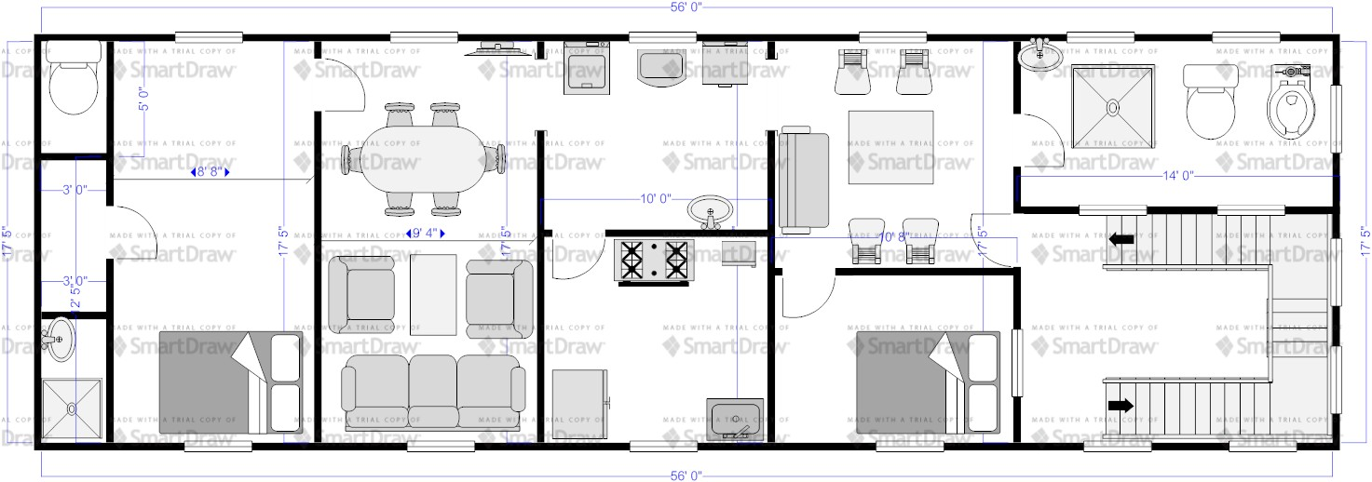

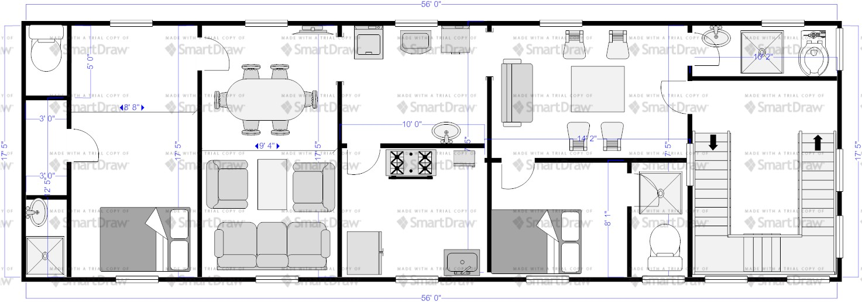
The above two floor plans are:

- West facing entrance with smaller stair case width
- West facing entrance with larger stair case width

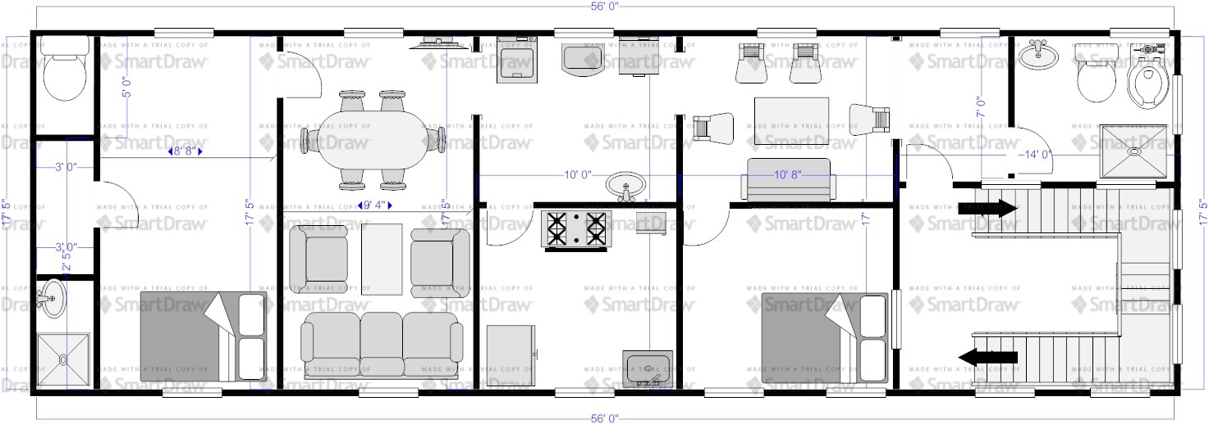
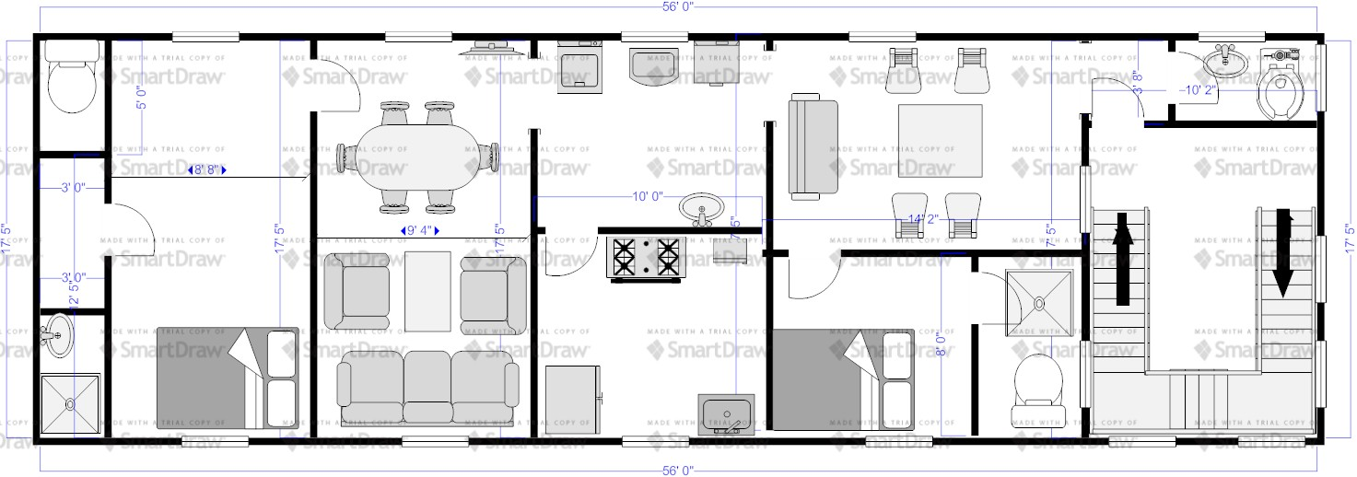
The above two floor plans are:

- North facing entrance with smaller stair case width
- North facing entrance with larger stair case width

